Chapter 5: How Ecosystems Work
Section 1, Energy Flow in Ecosystems

Life Depends on the Sun
- Energy from the sun enters an ecosystem when plants use sunlight to make sugar molecules.
- This happens through a process called _______________________________________.
Life Depends on the Sun
- Photosynthesis is the process by which plants, algae, and some bacteria use _______________________________________________________________________________.
- End result of photosynthesis is a ____________________________________________________.
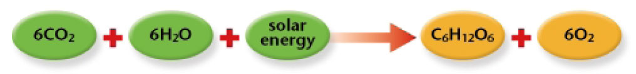
- Gives you energy to do daily activities

From Producers to Consumers
- Because plants make their own food, they are called _______________________________.
- A producer is an organism that can make ____________________________________________________.
- Producers are also called ___________________________________________________.
From Producers to Consumers
- Organisms that get their energy by eating other organisms are called ______________________________________.
- A consumer is an organism that eats ____________________________________________________ instead of producing its own nutrients or obtaining nutrients from inorganic sources.
- Consumers are also called _______________________________________________________________.
From Producers to Consumers
- Some producers get their energy directly from the sun by absorbing it through their leaves.
- Consumers get their energy indirectly by eating producers or other consumers.
An Exception to the Rule
- Deep-ocean communities of worms, clams, crabs, mussels, and barnacles, exist in total darkness on the ocean floor, where photosynthesis cannot occur.
- The producers in this environment are ______________________________________________ present in the water.
- Other underwater organisms eat the bacteria or the organisms that eat the bacteria.
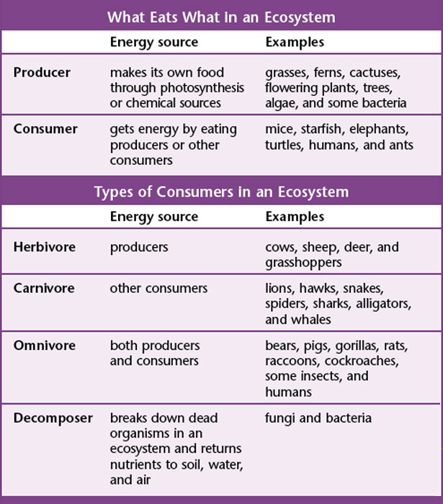
What Eats What?
- Organisms can be classified by what they eat.
- Types of Consumers:
  - Herbivores – ________________________________________
  - Carnivores – ________________________________________
  - Omnivores – ________________________________________
  - Decomposers – ______________________________________
What Eats What?
- Consumers that eat producers to get energy are what we call ___________________________________.
- In other words they are _____________________________________.
- Most of the energy will be used up by the consumer (herbivore).
- A consumer that eats another consumer is called a ___________________________________________.
Burning the Fuel
- An organism obtains energy from the food it eats.
- This food must be broken down within its body.
- The process of breaking down food to yield energy is called ________________________________________.
Burning the Fuel
- Cellular respiration is the process by which cells produce ___________________________________________________________; atmospheric oxygen combines with glucose to form water and carbon dioxide.
- Cellular respiration occurs inside the _____________________________ of most organisms.
Burning the Fuel
- During cellular respiration, cells _________________________________________________________________________________________.
- Through cellular respiration, cells use __________________________________________ and oxygen to produce carbon dioxide, water, and energy.
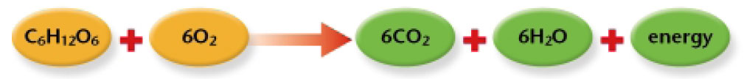

Burning the Fuel
- Part of the energy obtained through cellular respiration is used to carry out daily activities.
- Excess energy is stored as ______________________________________.
Energy Transfer
- Each time an organism eats another organism, an _______________________________ occurs.
- This transfer of energy can be traced by studying ___________________________________________________________________________________.
Food Chains
- A ____________________________________ is a sequence in which energy is transferred from one organism to the next as each organism eats another organism.
Food Webs
- Ecosystems, however, usually contain more than one food chain.
- A __________________________________________ shows many feeding relationships that are possible in an ecosystem.
Trophic Levels
- Each step in the transfer of energy through a food chain or food web is known as a ______________________________________________.
- A trophic level is one of the ______________________________________________________________; examples include producers and primary, secondary, and tertiary consumers.
Trophic Levels
- Each time energy is transferred, some of the energy is lost as ___________________________.
- Therefore, _____________________________________ is available to organisms at higher trophic levels.
- One way to visualize this is with an ____________________________________.
Trophic Levels
- Each layer of the pyramid represents one ________________________________ level.
- Producers form the ______________________________ of the energy pyramid, and therefore contain the _____________________________________________________.
- The pyramid becomes smaller toward the top, where less energy is available.
Energy Loss Affects Ecosystems
- Decreasing amounts of energy at each trophic level affects the organization of an ecosystem.
- Energy loss affects the ______________________________________ at each level.
- Energy loss limits the _______________________________________ in an ecosystem.

Chapter 5: How Ecosystems Work
Section 2, The Cycling of Materials

The Carbon Cycle
- The ___________________________________ is the movement of carbon from the nonliving environment into living things and back
- Carbon is the essential component of _______________________________________________________ which make up all organisms.
The Carbon Cycle
- Carbon exists in _________________________________________________________.
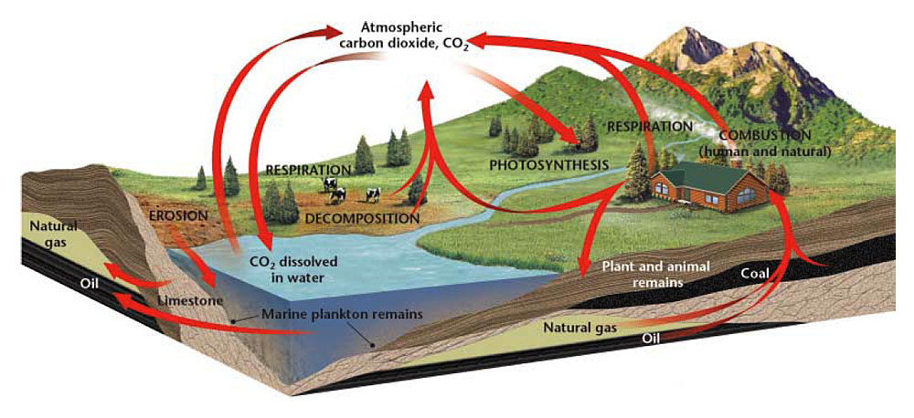
- Producers convert _____________________________________________ in the atmosphere into carbohydrates during photosynthesis.
- Consumers obtain carbon from the carbohydrates in the producers they eat.
The Carbon Cycle
- During cellular respiration, some of the carbon is released back into the atmosphere as _________________________________________.
- Some carbon is stored in ________________________________, forming one of the largest ________________________________ on Earth.
The Carbon Cycle
- Carbon stored in the bodies of organisms as __________________________________________________________, may be released into the soil or air when the organisms dies.
- These molecules may form deposits of __________________________________________________________, which are known as _______________________________________.
- Fossil fuels store carbon left over from bodies of organisms that dies millions of years ago.
How Humans Affect the Carbon Cycle
- Humans burn fossil fuels, releasing carbon into the atmosphere.
- The carbon returns to the atmosphere as __________________________________.
How Humans Affect the Carbon Cycle
- Increased levels of carbon dioxide may contribute to __________________________________________.
- Global warming is an _____________________________________________ of the Earth.
The Nitrogen Cycle
- The _____________________________________ is the process in which nitrogen circulates among the air, soil, water, plants, and animals in an ecosystem.
- All organisms need nitrogen to __________________________________, which are used to build new cells.
- Nitrogen makes up ____________________ percent of the gases in the atmosphere.
The Nitrogen Cycle
- Nitrogen must be _____________________________________, before organisms can use it.
- Only a few species of bacteria can fix atmospheric nitrogen into chemical compounds that can be used by other organisms.
- These bacteria are known as ________________________________________ bacteria.
The Nitrogen Cycle
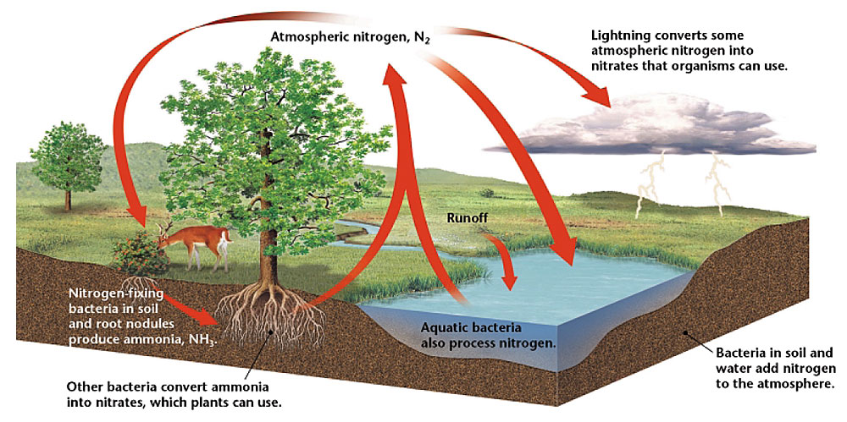
- ______________________________________________ are bacteria that convert atmospheric nitrogen into ammonia.
- These bacteria live within the roots of plants called ______________________________, which include beans, peas, and clover.
- The bacteria use sugar provided by the legumes to produce nitrogen-containing compounds such as _________________________.
- Excess nitrogen fixed by the bacteria is released into the soil.
Decomposers and the Nitrogen Cycle
- Nitrogen stored within the bodies of living things is returned to the nitrogen cycle once those organisms die.
- ________________________________________ break down decaying plants and animals, as well as plant and animal wastes.
- After decomposers return nitrogen to the soil, bacteria transform a small amount of the nitrogen into ___________________________________, which then returns to the atmosphere to complete the nitrogen cycle.
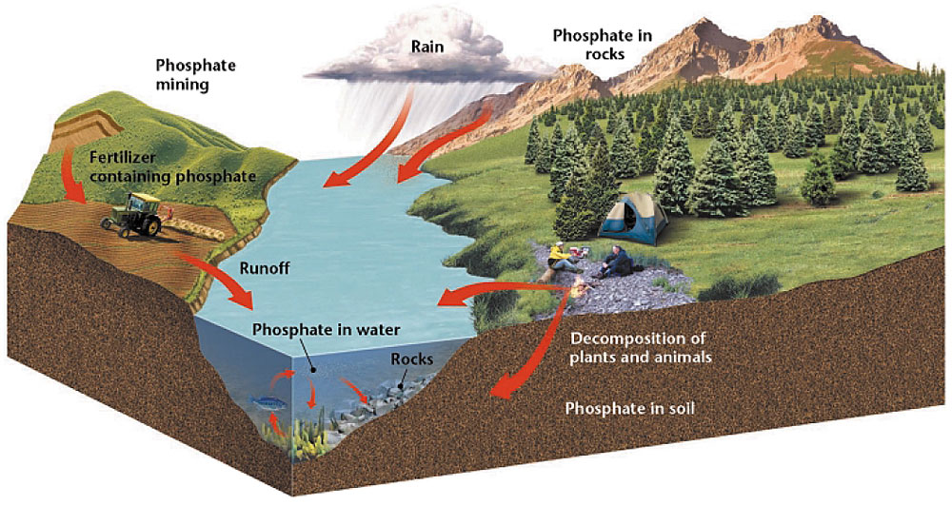
The Phosphorus Cycle
- ___________________________________ is an element that is part of many molecules that make up the cells of living organisms.
- Plants get the phosphorus they need from ___________________________, while animals get their phosphorus by ___________________________________________ that have eaten plants.
- The ___________________________________________ is the cyclic movement of phosphorus in different chemical forms from the environment to organisms and then back to the environment.
The Phosphorus Cycle
- Phosphorus may enter soil and water when rocks erode.
- Small amounts of phosphorus dissolve as _____________________________, which moves into the soil.
- Plants absorb phosphates in the soil through their roots.
- Some phosphorus washes off the land and ends up in the ocean.
- Because many phosphate salts are not soluble in water, they sink to the bottom and ______________________________________________.

Fertilizers and the Nitrogen and Phosphorus Cycles
- ______________________________, which people use to stimulate and maximize plant growth, contain both nitrogen and phosphorus.
- Excessive amounts of fertilizer can enter terrestrial and aquatic ecosystems through ______________________________________.
- Excess nitrogen and phosphorus can cause ___________________________________________________________.
- Excess algae can deplete an aquatic ecosystem of important nutrients such as _________________________________, on which fish and other aquatic organisms depend.
Acid Precipitation
- When fuel is burned, large amounts of _________________________________ is release into the atmosphere.
- In the air, nitric oxide can combine with oxygen and water vapor to form ____________________________________.
- Dissolved in rain or snow, the nitric acid falls as ______________________________________.

Chapter 5: How Ecosystems Work
Section 3, How Ecosystems Change

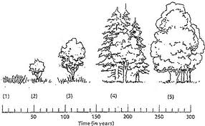
Ecological Succession
- Ecosystems are constantly changing.
- ________________________________________ is a gradual process of change and replacement of the types of species in a community.
- Each new community that arises often makes it harder for the previous community to survive.
Ecological Succession
- ________________________________________ is a type of succession that occurs on a surface where ________________________________________.
- It begins in an area that previously did not support life.
- Primary succession can occur on ____________________________________________________.
Ecological Succession
- ________________________________________________ occurs on a surface where an ecosystem has ________________________________________________.
- It is the process by which one community replaces another community that has been _____________________________________________________.
- Secondary succession can occur in ecosystems that have been _____________________________________________________ by humans, animals, or by natural process such as storms, floods, earthquakes, or volcanic eruptions.
Ecological Succession
- A _______________________________________________ is a species that colonizes an ________________________________________________ and that starts an ecological cycle in which many other species become established.
- Over time, a pioneer species will make the new area habitable for other species.
- A ___________________________________________ is the final, stable community in equilibrium with the environment.
- Even though a climax community may change in small ways, this type of community may remain the same through time if it is not disturbed.
Ecological Succession
- ____________________________________________ caused by lightning are a necessary part of secondary succession in some communities.
- Minor forest fires remove _______________________________________________________ that would otherwise contribute to major fires that burn out of control.
- Some animal species also depend on occasional fires because they feed on the vegetation that sprouts after a fire has cleared the land.
Ecological Succession
- _____________________________________________ is a type of _________________________________ succession that occurs when farmland is abandoned.
- When a farmer stops cultivating a field, grasses and weeds quickly grow and cover the abandoned land.
- Over time, taller plants, such as perennial grasses, shrubs, and trees take over the area.
Ecological Succession
- ______________________________________________ can occur on new islands created by _________________________________________________________.
- Primary succession is much slower than secondary succession. This is because it begins where there is no soil.
Ecological Succession
- The first pioneer species to colonize bare rock will probably be _______________________________________, which can live without soil.
- The growth of lichens _____________________________________________, which with the action of water, begins to form soil.

