Reindeer of St. Matthew Island

Introduction
Every ecosystem has a carrying capacity for each of the organisms in it. Carrying capacity is defined as the number of individuals within a species that the ecosystem can support over the long-term. When a population grows so quickly that it exceeds the carrying capacity, an overshoot occurs. This can be disastrous, as a lack of resources will lead to wide-spread death due to starvation or disease. The resulting drop in population is called a dieback. This activity will show you one famous example of a population that overshot its carrying capacity.

The Story
In August of 1944, the United States coast guard captured and transported 29 reindeer from Nunivak Island and floated them 200 miles north on a barge to St. Matthew Island. This island is one of the most remote places in Alaska. The Coast Guard had a small manned station here, and the reindeer herd was intended to be a food source. The only potential predator for the reindeer on this island was Arctic fox, which are too small to kill anything but newly born reindeer calves.

Locate St. Matthew Island (60.4°N, 172.7°W) and Nunivak Island (60.4°N, 166.1°W) on this map. Draw an arrow to show the movement of the reindeer on the barge.
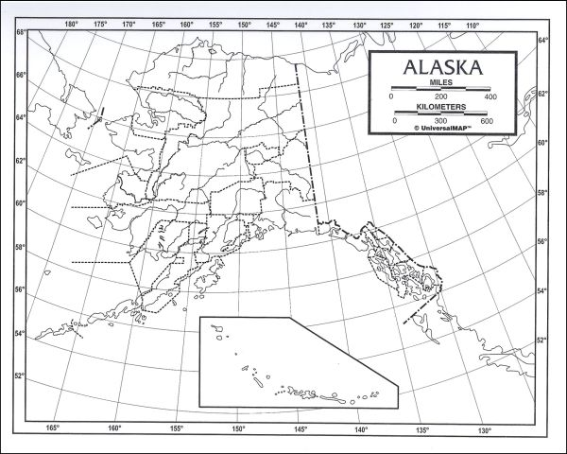

The reindeer primarily used lichen as a food source. Lichen is a combination of a fungus and an algae that live in a mutualistic relationship. Lichen grow very slowly in Arctic regions such as this. World War II ended soon after the reindeer were introduced, so none of them were ever actually hunted by the Coast Guard officers. The island was abandoned by humans, and the deer were left without any predators. In these conditions, their population thrived.

A biologist working for the U.S. Fish and Wildlife Service began making regular visits to the island. In 1957 he counted 1,350 reindeer. He also noted that many of the lichen patches appeared trampled and barren.

Graph the reindeer population from 1944-1963.

Year | Population of Reindeer
1944 | 29
1945 | 37
1946 | 54
1947 | 81
1948 | 104
1949 | 139
1950 | 177
1951 | 240
1952 | 313
1953 | 398
1954 | 501
1955 | 630
1956 | 878
1957 | 1,350
1958 | 1,918
1959 | 2,840
1960 | 3,688
1961 | 4,040
1962 | 4,933
1963 | 6,000

The biologist noted the population continued to rise, but the health of the herd seemed to be decreasing. Finally, when he returned to the island again in 1966, he observed only 42 remaining reindeer. The island was covered with thousands of skeletons. Add this data to the graph above.

Of the 42 remaining reindeer, only one was male. The male was observed t o have irregularly shaped antlers, and probably had some sort of genetic defect. By 1967, the reindeer were completely absent from the island. Add this data to the graph above.

Analysis

- Based on the graph above, did the reindeer show exponential or logistic growth?

- Why did the reindeer grow at this rate?

- Based on the graph above, what do you think the carrying capacity of this island was for reindeer? Explain how you came to this answer.

- Why is it bad to for a population to overshoot the carrying capacity of an ecosystem?

- If the Coast Guard were to try this again on a similar island, what changes could they make to prevent the same outcome?

- Critics of this story will argue that one of the factors that contributed to the population crash of the deer was a severe winter that created snow too deep for many of the reindeer to dig through for food. Does this mean the deer would not have experienced a dieback if not for the blizzard? How does this new information change your perspective on this event?

