El Nino Southern Oscillation: Explanation
El Niño is an oscillation of the ocean-atmosphere system in the tropical Pacific having important consequences for weather around the globe.
Among these consequences are increased rainfall across the southern tier of the US and in Peru, which has caused destructive flooding, and drought in the West Pacific, sometimes associated with devastating brush fires in Australia. Observations of conditions in the tropical Pacific are considered essential for the prediction of short term (a few months to 1 year) climate variations. To provide necessary data, NOAA operates a network of buoys which measure temperature, currents and winds in the equatorial band. These buoys daily transmit data which are available to researchers and forecasters around the world in real time.
In normal, non-El Niño conditions, the trade winds blow towards the west across the tropical Pacific. These winds pile up warm surface water in the west Pacific, so that the sea surface is about 1/2 meter higher at Indonesia than at Ecuador.
The sea surface temperature is about 8 degrees C higher in the west, with cool temperatures off South America, due to an upwelling of cold water from deeper levels. This cold water is nutrient-rich, supporting high levels of primary productivity, diverse marine ecosystems, and major fisheries. Rainfall is found in rising air over the warmest water, and the east Pacific is relatively dry.
Click for full size image
(will open a new browser window)
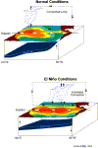 | 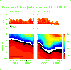
(a) | (b)
(a) Schematic diagram of normal El Niño conditions in the Pacific Ocean, and (b) temperature on the Equator at 110W
During El Niño, the trade winds relax in the central and western Pacific leading to a depression of the thermocline in the eastern Pacific, and an elevation of the thermocline in the west. This reduces the efficiency of upwelling to cool the surface and cut off the supply of nutrient rich thermocline water to the euphotic zone (top layer of ocean). The result was a rise in sea surface temperature and a drastic decline in primary productivity, the latter of which adversely affected higher trophic levels of the food chain, including commercial fisheries in this region. Rainfall follows the warm water eastward, with associated flooding in Peru and drought in Indonesia and Australia. The eastward displacement of the atmospheric heat source overlaying the warmest water results in large changes in the global atmospheric circulation, which in turn force changes in weather in regions far removed from the tropical Pacific. El Nino occurs every 3-8 years.
In the Pacific, La Niña is characterized by unusually cold ocean temperatures in the eastern equatorial Pacific, compared to El Niño, which is characterized by unusually warm ocean temperatures in the same area. Atlantic tropical cyclone activity is generally enhanced during La Niña. The La Niña condition often follows the El Niño, especially when the latter is strong.

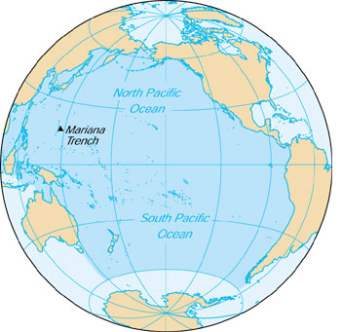
Normal, Non ENSO Conditions ENSO Conditions

El Nino Southern Oscillation Effects | Environmental/Human Impacts

