Chapter 1
Science and the Environment
Section 1: Understanding Our Environment
Day 2

Our Environment through Time Continued: Improving the Quality of Life
- The ______________________________________________________ introduced many positive changes such as the light bulb.
- Agricultural productivity _____________________________, and sanitation, nutrition, and medical care vastly ______________________________.
Improving the Quality of Life
- However, the Industrial Revolution also introduced many new environmental problems such as _____________________________________________.
- In the 1900s, modern societies began to use ___________________________________ in place of raw animals and plant products.
- As a result, we know have materials such as ______________________________________________________________________.
Improving the Quality of Life
- Many of these products make life easier, but we are now beginning to understand some of the environmental problems they present.
- In fact, much of environmental science is concerned with the problems associated with the Industrial Revolution.
Spaceship Earth
- Earth can be compared to a spaceship traveling through space as it cannot dispose of its waste or take on new supplies.
- Earth is essentially a ______________________________________.
- This means that the only thing that enters the Earth’s atmosphere in large amounts is _____________________________________________, and the only thing that leaves in large amounts is ________________________________.
Spaceship Earth
- This type of closed system has some potential problems.
- Some resources are limited and as the population grows, the resources will be used more rapidly.
- There is also the possibility that we will produce wastes more quickly than we can dispose of them.
Spaceship Earth
- Environmental problems can occur on different scales: _____________________________________________________________________.
  - A local example would be your community discussing where to build a new _______________________________________.
  - A regional example would be a polluted river ______________________________________________________________.
  - A global example would be the ______________________________________________________________.
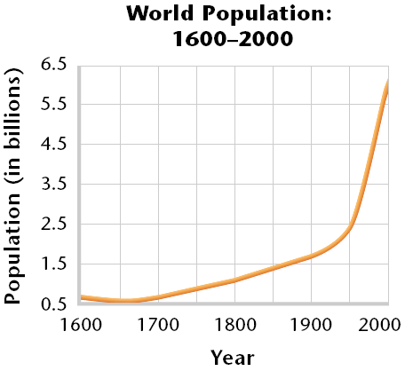
Population Growth
- The Industrial Revolution, modern medicine, and sanitation all allowed the human population to ______________________________________ than it ever had before.

Population Growth
- In the past 50 years, nations have used vast amounts of resources to meet the worlds need for food.
- Producing enough food for large populations has environmental consequences such as __________________________________________________.
Population Growth
- Most scientists think that the human population will almost double in the 21st century before it begins to stabilize.
- Because of these predictions, we can expect the pressure on the environment will continue to increase, the human population and its need for food and resources grow.
What are our Main Environmental Problems?
- Environmental problems can generally be grouped into three categories:
  - ____________________________________________ _____________________________________________
  - ____________________________________________
Resource Depletion
- __________________________________________ are any natural materials that are used by humans, such as, water, petroleum, minerals, forests, and animals.
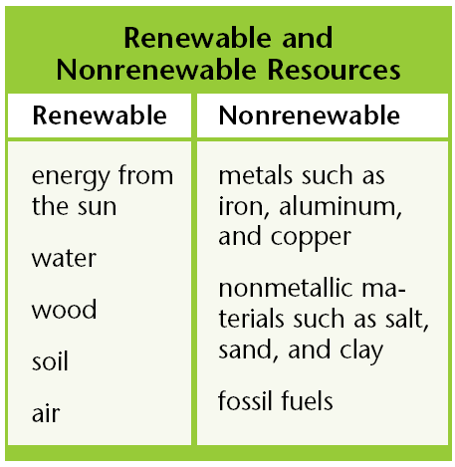
- Natural resources are classified as either a _____________________________________________________.
Resource Depletion
- _______________________________________________ can be replaced relatively quickly by natural process.
- _______________________________________________ form at a much slower rate than they are consumed.
Resource Depletion
- Resources are said to be ___________________________ when a large fraction of the resource has been used up.
- Once the supply of a nonrenewable resource has been used up, it may take millions of years to replenish it.
- Renewable resources, such as trees, may also be depleted causing deforestation in some areas.
Pollution
- ______________________________________ is an undesirable change in the natural environment that is caused by the introduction of substances that are harmful to living organisms or by excessive wastes, heat, noise, or radiation
- Much of the pollution that troubles us today is produced by _____________________________________________________________________.
Pollution
- There are two main types of pollutants:
  - _______________________________________________, which can be broken down by natural processes and include materials such as newspaper.
  - _______________________________________________, which cannot be broken down by natural processes and include materials such as mercury.
Pollution
- Degradable pollutants are a problem only when they ____________________________________________ than they can be broken down.
- However, because nondegradable pollutants do not break down easily, they can build up to dangerous levels in the environment.
Loss of Biodiversity
- __________________________________________ is the variety of organisms in a given area, the genetic variation within a population, the variety of species in a community, or the variety of communities in an ecosystem.
- The organisms that share the world with us can be considered natural resources.
- We depend on them for food, the oxygen we breathe, and for many other things.
Loss of Biodiversity
- Yet, only a fraction of all the species that once roamed the Earth are alive today and many are extinct.
- Scientists think that if the current extinction rates continue, it may cause problems for the human population.
- Many people also argue that all species have potential economic, scientific, aesthetics, and recreational value, so it is important to preserve them.

