Name: __________________________________ Date: _____________

ACID RAIN LAB
OBJECTIVES
-To explain how acid rain forms and observe the pH of unpolluted & acid rain.
-To explain the effects of acid rain on human-made structures.

ACTIVITY 1: pH of Unpolluted Rain
How Do We Measure Acid Rain?
Whether a liquid is an acid or a base is measured using the pH scale. It ranges from 0 to 14. A pH of 7 is neutral. A pH less than 7 is acidic, and a pH greater than 7 is basic. Mixing acids and bases can cancel out their extreme effects, just like mixing hot and cold water can even out the water temperature. Normal rain is slightly acidic because carbon dioxide (CO₂) dissolves in it and forms carbonic acid (H₂CO₃), which is a weak acid. For this reason, unpolluted rainwater is acidic, with a pH value of 5.0 to 5.6. Acid rain typically has a pH less than 5.0. In recent years, the most acidic rain falling in the US has a pH of about 4.0.

1. What # on the pH scale represents neutral? ____ Which numbers represent acidic solutions? ____ Basic solutions? ______

2. Why is normal rainfall slightly acidic?

3. What pH values could acid rain have?

MATERIALS (per group): 2 glass test tubes, straw, pipet, bromthymol blue, 10 mL tap water

PROCEDURE
1. Pipet 5 mL of tap water into the first test tube.
2. Add one drop of bromthymol blue, and determine if the pH of the water is acidic or basic. Record your observations below.
**NOTE: Bromthymol blue is a pH indicator that turns from dark blue to yellow when it contacts a weak acid, such as carbonic acid.
pH of tap water: _____________________________________
3. Pipet 5 mL of tap water into the second test tube. Have one of your group members exhale gently through a straw into the water for 30 seconds.
4. Add one drop of bromthymol blue, and determine if the pH of the water is acidic or basic.
pH observations: ____________________________________
5. Rinse the test tubes with clean water, dry them, and return them to their original locations.

Post-Lab Questions
What substance was formed as a result of exhaling into the tap water? How did this change the pH of the tap water?
_______________________________________________________________________________________________________________________________________________________________________________________________________________________________________________________________________________________________________________________

What does exhaling into the water simulate from the environment?
_______________________________________________________________________________________________________________________________________________________________________________________________________________________________________________________________________________________________________________________

Activity 2: pH of Acid Rain
What is Acid Rain and What Causes It?
Acid rain is a broad term used to describe several ways that acids fall out of the atmosphere. A more precise term is acid deposition, which has two parts: wet and dry. Wet deposition refers to acidic rain, fog, and snow. As this acidic water flows over and through the ground, it affects a variety of plants and animals. The strength of the effects depend on many factors, including how acidic the water is, the chemistry and buffering capacity (the ability to neutralize acidic compounds) of the soils involved, and the types of fish, trees, and other living things that rely on the water.

Dry deposition refers to acidic gases and particles. The wind blows these acidic particles and gases onto buildings, cars, homes, and trees. Acidic gases and particles can also be washed from trees and other surfaces by rainstorms. When that happens, the runoff water adds those acids to the acid rain, making the combination more acidic than the falling rain alone. Prevailing winds blow the compounds that cause both wet and dry acid deposition across state and national borders, and sometimes over hundreds of miles.

Scientists have confirmed that sulfur dioxide (SO₂) and nitrogen oxides (NO_{x}) are the primary causes of acid rain. Natural events such as volcanic eruptions, forest fires, hot springs, and natural geysers produce sulfur dioxide & nitrogen oxide gases. Human activity, though, makes a large contribution. The major sources of sulfur dioxide are coal-burning power plants, whereas the major sources of anthropogenic nitrogen oxides are motor vehicles & coal-burning power plants. Acid deposition occurs when these gases react in the atmosphere with water, oxygen, and other chemicals to form various acidic compounds. Sunlight increases the rate of most of these reactions. The result is a mild solution of sulfuric acid (H₂SO₄) and nitric acid (HNO₃).

1. What are the two parts to acid deposition? Give an example of each.

2. How are winds involved in where acid deposition falls?

3. What two compounds are the primary causes of acid rain? List the primary source for each.

4. How is acid rain formed in the atmosphere? Include the 2 chemical compounds that are the ACID in acid rain.

MATERIALS (per group): glass test tube, test tube tongs, bromthymol blue, match

PROCEDURE:
1. Start with a dry test tube. Shake out any water in the test tube before proceeding.
2. Place 3 drops of bromthymol blue in the test tube.
3. Tilt and rotate the test tube so that the liquid coats the inner surface of the test tube.
4. Using the tongs, hold the test tube upside down. Determine if the bromthymol blue drops indicate an acid or base.
pH Observations of Test Tube: _______________________________________________
5. Light a match and hold the flame beneath the inverted test tube, allowing the smoke to rise into the tube. Hold the match for a few seconds only, and immediately extinguish the flame to avoid burning yourself.
6. Determine if the pH of the bromthymol blue indicates an acid or a base.
pH Observations after lighting match: __________________________________________
7. Rinse the test tube, dry it, and return materials to their original locations.

Post-Lab Questions
What gas does the burning match release? _______________

Why did the pH of the bromthymol blue change as the match burned? (In other words, how does the reaction occurring inside the test tube simulate the reactions occurring in the atmosphere to form acid rain?)
____________________________________________________________________________________________________________________________________________________________________________________________________________________________________________________________________________________________________________________________________________________________________________________________________________________________________________

Activity 3: Effects of Acid Rain on Human-Made Structures
Acid deposition has a variety of effects, including damage to forests and soils, fish and other living things, materials, and human health. Acid rain causes acidification (lowering of the pH) of lakes and streams and contributes to damage of trees at high elevations and many sensitive forest soils. Acid damages trees leaves, reducing a tree’s ability to carry out photosynthesis, and damages bark, leaving the tree vulnerable to insects and disease. The acid can remove the waxy coating on tree leaves and burn the leaves, leaving brown spots. Acid also releases toxic aluminum ions from the soil, which can damage plant roots.

Acid deposition has had severe impacts on aquatic organisms in lakes and streams as well. Aquatic animals are adapted to living In an environment with a specific pH range. If acid rain falls on a lake and makes the lake more acidic, it can kill aquatic plants, fish, and other aquatic animals. It also causes aluminum to leach out of the soils around a lake, which can build up in fish gills and eventually suffocate them. Acid deposition also affects reproduction, causing fish and amphibians to produce fewer eggs, prevents eggs from hatching or causing birth defects in surviving young.

In addition, acid rain accelerates the decay of building materials and paints, including irreplaceable buildings, statues, and sculptures that are part of our nation's cultural heritage. Many ancient statues and buildings are made of two different forms of calcium carbonate (CaCO₃): marble and limestone. Both marble and limestone react with acid deposition, causing them to turn black and simply dissolve over time. Acid deposition also affects manufactured materials, corroding metals & damaging paints and coatings meant to protect items from rust.

The pollutants that cause acid deposition also threaten human health. Lung cancer, asthma, bronchitis, and emphysema can be caused and aggravated by air pollutants. For example, cases of respiratory ailments are 50% higher in the most polluted parts of Poland, Hungary, and the Czech Republic than in the cleaner areas of those countries. The US is not immune to this problem. Senior citizens, children, and people with weakened immune systems are advised to stay inside during times of peak air pollution in many metropolitan cities.

1. How does acid deposition impact the daily functions and survival of plants?

2. How does acid deposition impact the daily functions and survival of aquatic animals?

2. Which types of man-made materials may experience the greatest effect of acid deposition?

3. What types of diseases can be caused by, or made worse by, air pollution?

Materials (per group): chalk, mossy zinc, mortar & pestle, 40 mL 0.05 M sulfuric acid, 2 beakers, graduated cylinder

Procedure
1. Using a mortar and pestle, crush half of a piece of chalk into small pieces. The chalk should be crushed, NOT powdered.
2. Place the chalk in a small beaker.
3. Using the graduated cylinder, measure and pour 20 mL of 0.05 M sulfuric acid (“concentrated acid rain”) into each of the beakers.
4. Observe and compare the reactions of the samples for five minutes. Record your observations below.
Observations of chalk & acid rain:
___________________________________________________________________________________________________________
Observations of mossy zinc & acid rain:
___________________________________________________________________________________________________________
5. After 5 minutes, dump any unused chalk & dispose of the used sulfuric acid in the sink. Please be sure to wash it down with plenty of water. The mossy zinc can be rinsed & returned to the empty, clean beaker.
Post-Lab Questions
In this activity, chalk & zinc are used to simulate man-made structures. Based on your observations, explain how acid rain would impact limestone/marble or metal structures. How would the impacts be different between the two types of materials?
___________________________________________________________________________________________________________________________________________________________________________________________________________________________________________________________________________________________________________________________________________________________________________________________________________________________________________
__________________________________________________________________________________________________________
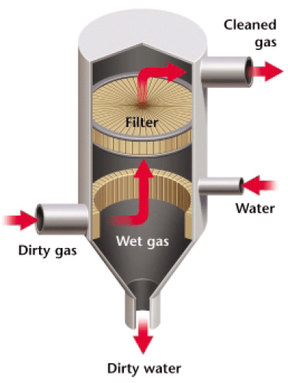
Solutions: Reducing Acid Deposition & Other Air Pollutants
Fossil fuel power plants and industries are important sources of both sulfur dioxide and nitrogen oxides. About one-third of our air pollution in general comes from gasoline burned by vehicles. The Clean Air Act, passed in 1970 and strengthened in 1990, gives the Environmental Protection Agency (EPA) the authority to regulate vehicle and industrial emissions in the United States.

The Clean Air Act requires many industries to use scrubbers or other pollution-control devices. Scrubbers remove harmful substances such as sulfur dioxide, ammonia, or particulate matter, from the emissions released by power plants and factories. A scrubber is a machine that moves gases through a spray of water that dissolves many pollutants before they are released into the atmosphere (see picture to the right).
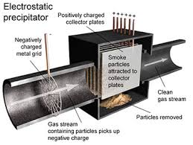
Electrostatic precipitators are machines used in cement factories and coal-burning power plants to remove dust particles from smokestacks (see picture to the left). Electrostatic precipitators are machines used in cement factories & coal-burning power plants to remove dust particles from smokestacks. In an electrostatic precipitator, gas containing dust particles is blown through a chamber containing an electric current. An electrical charge is transferred to the dust particles, which causes them to stick to one another and the sides of the chamber. The clean gas is released from the chamber, and the concentrated dust particles can then be collected and removed. Electrostatic precipitators remove 20 million tons of ash generated by coal power plants from the air each year in the U.S.

The Clean Air Act was updated in 1990 to include an allowance trading system, or cap-and-trade program, to reduce sulfur dioxide pollution and the occurrence of acid rain. In the allowance trading system, 1 ton of sulfur dioxide emission is equal to one ‘allowance.’ Power plants and factors that release large amounts of sulfur dioxide were given a limited number of allowances (sulfur dioxide) that they could release each year. Companies can buy, sell or trade their allowances, but if they go over their allowed sulfur dioxide emissions, they must pay a fine. The system allows a company to determine the most cost-effective ways to reduce their sulfur dioxide emissions and comply with the Clean Air Act requirements. Companies can reduce emissions by using renewable energy sources, updating their pollution-control devices, or using low-sulfur fuels (like burning natural gas instead of coal). Over time, the EPA reduces the total number of sulfur dioxide allowances to bring down the total amount of sulfur dioxide released in the country. The results of the program were immediate, reducing sulfur dioxide pollution by 50% in just the first 5 years of the program.
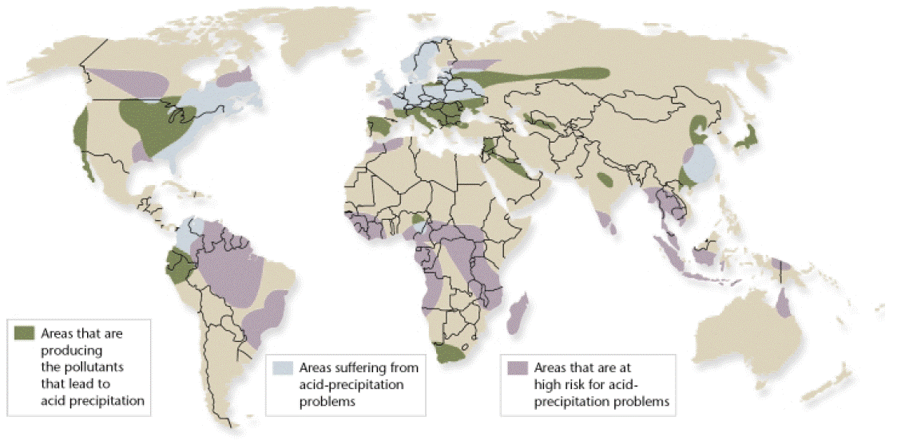
One problem in controlling acid precipitation is that pollutants may be released in one geographic area and fall to the ground hundreds of kilometers away. For example, almost half of the acid precipitation that falls in southeastern Canada results from pollution produced in Ohio, Indiana, Pennsylvania, Illinois, Missouri, West Virginia, and Tennessee. Because acid precipitation falls downwind, the problem of solving acid precipitation has been difficult, especially on the international level. In the spirit of cooperation, Canada and the United States signed the Canada-U.S. Air Quality Agreement in 1991. Both countries agreed to reduce acidic emissions that flowed across the Canada-U.S. boundary. More international agreements such as this may be necessary to control the acid-precipitation problem.

Individuals are also responsible for air pollution, and the EPA regulates vehicle emissions in the United States as well, under the Clean Air Act. The EPA required the gradual elimination of lead in gasoline, and as a result, lead pollution has been reduced by more than 90% in the U.S. In addition, catalytic converters, which are required in automobiles, clean exhaust gases of pollutants before the pollutants are able to exit the tailpipe (see picture to the right). The EPA estimates that cars and trucks today burn fuel 35% more efficiently and with 95% fewer emissions of pollutants, with the exception of carbon dioxide, than they did 30 years ago.

