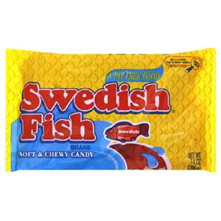
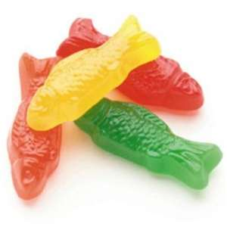

Tragedy of the Commons Lab
“Got Fish?”
Materials:
- Swedish Fish Candy
- Paper plate (lake)
- Drinking straws (2 taped together)
- Small Drinking cup (net)
Procedure 1:
- Students will be divided into groups of 4.
- Each “lake” has 4 fishers (students).
- Each “lake” will contain 16 fish (the only food source).
- Fish (Swedish Fish Candy) are the resource that can be harvested from the “lake” (paper plate). Each fish is worth $10.00. The more fish you catch, the more money you will earn.
- You catch fish by using:
  - “Fishing pole” (2 plastic drinking straws taped together, and using no hands)
  - You must fish by sucking up the “fish” from the “ocean” with the straws then placing them into the “net” (small plastic drinking cup).
- Fishing season lasts 1 minute. During the 1 minute, each fisher catches fish. You must catch at least one fish to survive and stay in the game. If you catch less than one, then you are dead and out of the game.
- The “fish” reproduce once a year. At the end of each fishing season, add one new fish to the ocean for each fish that remains in the lake. There are 6 fishing seasons you must complete.
  - See your teacher at the end of each year – each remaining fish is able to spontaneously reproduce and make one new fish (4 becomes 8 and so on)

Data: Fishing Log

Name of Fishers | Year 1 | Year 2 | Year 3 | Year 4 | Year 5 | Year 6 | Total Number of Each Fish for each Fisher
Total fish harvest from lake
Total income from lake

Discussion Questions:
- Discuss any significant trends in the carrying out of the fishing seasons.

- Did your group of students discuss actions and strategies before each fishing season? If so, please list these below.

- Did anyone in your group take too many fish? How did that make you feel?

- Compare your group’s results (fishing harvest to at least two other “lakes” close to you. Explain whether you think your group was successful in using the ocean’s resources sustainably.

- Mathematically, what would be the best strategy for harvesting fish or other common resources?

- Let’s say that last year a new family moved into the area. What happens to the fish harvest and income when there is another fishing family?

- Think of local commons that you are familiar with (parking lots, dorms, bathrooms, and etc). Do similar situations arise? Explain.

