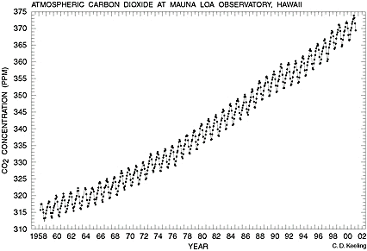
- The carbon dioxide graph to the right is often called the “Keeling Curve”. Why do the atmospheric CO₂ levels fluctuate up and down every year?

- Al Gore shows multiple pictures of glaciers that have melted significantly over the last few decades. Special attention was given to the glaciers of the Himalaya Mountains, due to the possibility they would disappear within the next 25 years. This statement, also found in the United Nations global warming report, was later retracted because it was based on the speculation of a single scientist, not actual data.
In your view, does this affect the documentary’s credibility?

- Al Gore claims that the effects of the Clean Air Act of 1970 are visible in the Antarctic ice cores. This is actually inaccurate, as the effects are only visible from ice cores taken from the Arctic. Regardless, does this claim relate in any way to carbon dioxide pollution? Explain.

- This is the graph of carbon dioxide concentration and surface temperature as recorded from ice core data.

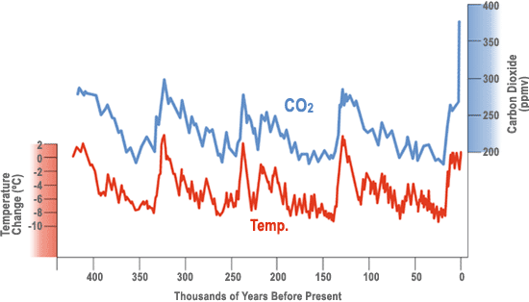

Is the relationship between CO2 and temperature a direct one? What would be a reasonable conclusion to draw from this graph?

- As a conclusion to this segment, Al Gore makes the following statement:

“This is really not a political issue so much as a moral issue. If we allow that to happen, it is deeply unethical.”

Do you believe this is a moral issue? Is the continued increase in carbon dioxide pollution by the human civilization deeply unethical? Explain your reasoning.
- Why does snow and ice reflect much of the sun’s infrared energy, while ocean water absorbs it?
- The map below shows the relative contribution of each of the major countries/continents to global warming. Why is the United States the greatest contributor, even though we have a lower population than China or the entirety of Europe?
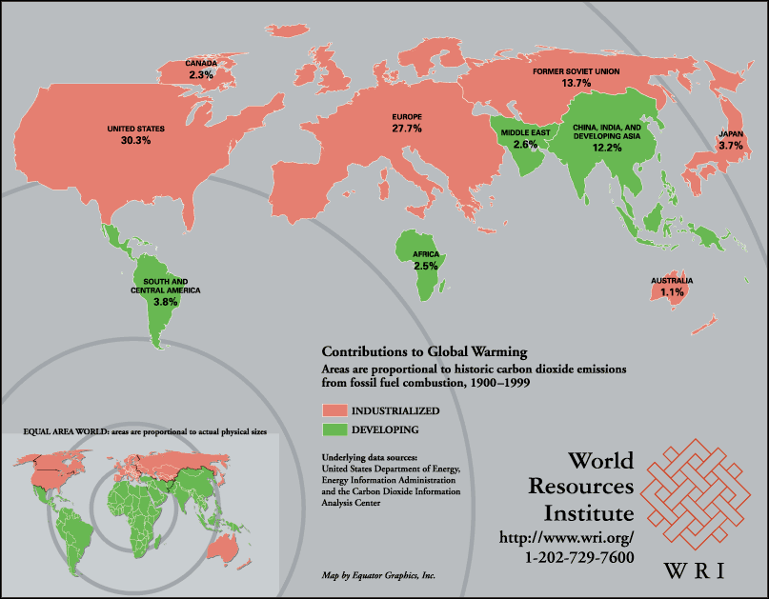

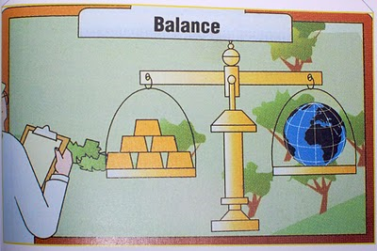
- The conflict between the economy and the environment is summarized in this image from a White House conference. Explain, in your own words, the decision we as a civilization are faced with.
- The Tragedy of the Commons is an essay written by Garrett Hardin about the abuse of natural resources that are not owned but shared by everyone. The two cartoons below summarize the essay.
http://www.garretthardinsociety.org/info/cartoon_commons1.html

http://www.garretthardinsociety.org/info/cartoon_commons2.html

Would you consider global warming and carbon dioxide pollution to be an example of a Tragedy of the Commons? Explain your answer.

