Chapter 1
Science and the Environment
Section 2: The Environment and Society
Day 1
“The Tragedy of the Commons”
- In his essay, ecologist ________________________________________ argued that the main difficulty in solving environmental problems is the conflict between the short-term interests of the individual and the long-term welfare of society.
- The example he used was the __________________________________, or the areas of land that belonged to the whole village.
“The Tragedy of the Commons”
- It was in the best interest of the individual to put as many animals in the commons as possible.
- However, if too many animals grazed on the commons, they destroyed the grass.
- Once the grass was destroyed, everyone suffered because no one could raise animals on the commons.
“The Tragedy of the Commons”
- The commons were eventually replaced by _____________________________________________________________________.
- Owners were now careful not to put too many animals on their land, because overgrazing wouldn’t allow them to raise as many animals next year.
- Hardin’s point being that ______________________________________________________________________.
“The Tragedy of the Commons”
- Hardin’s point can be applied to our modern commons, natural resources.
- Humans live in societies, and in societies, we can solve environmental problems by ______________________________________________________________________.
- The solution may be to override the short-term interests of the individual and improve the environment for everyone in the end.
Supply and Demand
- ______________________________________________________ is a law of economics that states as the demand for a good or service increases, the value or the food or service also increases.
- An example is the world _______________________________________________.

Costs and Benefits
- The cost of environmental solutions can be high.
- A _________________________________________ balances the cost of the action against the benefits one expects from it.
- The results depend on who is doing the analysis.
- For example, pollution control may be too costly to an industry, but to a nearby community, the price may well be worth it.
- Often, environmental regulations are passed on to ______________________________________________________.
Risk Assessment
- One of the costs of any action is the risk of an undesirable outcome.
- _______________________________________________ is a tool that helps us create cost effective ways to protect our health and environment.
- To come up with an effective solution to an environmental problem, the public must perceive the risk accurately.
Developed and Developing Countries
- The unequal distribution of wealth and resources around the world influence the environmental problems and solutions a society can make.
- ________________________________________ have higher incomes, slower population growth, diverse industrial economies, and stronger social support.
- ________________________________________ have lower average incomes, simple agriculture-based communities, and rapid population growth.
Population and Consumption
- Almost all environmental problems can be traced back to two root causes:
  - ____________________________________________________________________________________________________________________________________
  - ____________________________________________________________________________________________________________________________________
Local Population Pressures
- When the population in an area grows rapidly, there may not be enough natural resources for everyone to live a healthy, productive life.
- In severely overpopulated regions, forests are stripped bare, topsoil is exhausted, and animals are driven to extinction.
- In these areas, malnutrition, starvation, and disease can be constant threats.
Local Population Pressures
- In ____________________________________________, millions of people are starving.
- Yet these human populations tend to grow the fastest.
- Food production, education, and job creation cannot keep pace with the population growth, so each person gets fewer resources as time goes by.
Consumption Trends
- To support the higher quality of life, ________________________________________ are using much more of Earth’s resources.
- Developed nations use about _____________ percent of the world’s resources, although they make up only ________________ percent of the world’s population.
- This rate of consumption creates more waste and pollution per person then in developing countries.
Ecological Footprints
- __________________________________________________ are calculations that show the productive area of Earth needed to support one person in a particular country.
- An ecological footprint estimates the land used for ______________________________________________________________________.
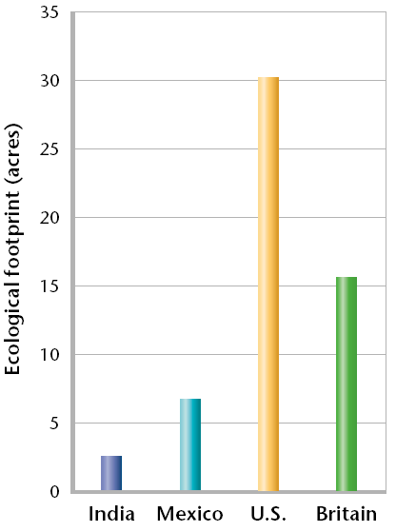
- It also includes the ocean area used to harvest seafood and the forest area needed to absorb the air pollution caused by fossil fuels.
Ecological Footprints
- An ecological footprint is one way to express the
_________________________________________________.
Critical Thinking and the Environment
- People on either side on an environmental issue may feel passionately about their cause and can distort information to mislead people about the issue.
- Research done by scientists is often used to make a political point or is misinterpreted to support controversial data.
Critical Thinking and the Environment
- In addition, the economic dimension of an environmental issue may be oversimplified and to complicate matters still, the media often sensationalizes environmental issues.
- For these reasons and others, you must use your critical thinking skills when making decisions about environmental issues.
Critical Thinking and the Environment
- Remember a few things as you explore environmental science further:
  - ____________________________________________________________________________________________________________________________________
  - ____________________________________________________________________________________________________________________________________
  - ____________________________________________________________________________________________________________________________________
A Sustainable World
- ___________________________________________ is the condition in which human needs are met in such a way that a human population can survive indefinitely.
- Sustainability is a key goal of environmental science.
A Sustainable World
- A sustainable world is not unchanging as technological advances and human civilizations continue to be productive.
- However, our current world is not sustainable as the developed countries are using resources faster than they can be replaced.
- Achieving a sustainable world requires everyone’s participation including individual citizens, industry, and the government.

