Name: _____________________________ Date:__________
Biomes Webquest
Directions: Look around on the websites to find the answers to the following questions. Answer all questions completely.
Go to: http://www.blueplanetbiomes.org/world_biomes.htm
1. What are the 4 main aspects of a biome?
2. Describe the leaves of trees that live in the taiga.
2. How do trees in the taiga protect themselves from fire?
3. The changing of 4 distinct seasons is best viewed in which biome?
4. Write down the average rainfall of all the biomes (HINT: click on the climate section of each biome).
 | Tundra | Taiga | Grasslands | Deciduous Forest | Chaparral | Desert | Savanna | Rainforest | Alpine
Rainfall
Based on rainfall, which biomes could be classified as a desert?
5. Identify the plants and their biomes below. (HINT: You will need to find the Plants link at the bottom of the home page.)
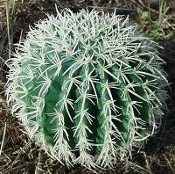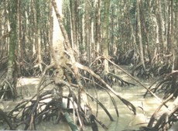
How have these plants adapted to their environment?

6. What does the term deciduous mean?
7. What is the main difference between a hot and a cold desert (besides temperature)?
8. Name three of the four major deserts of North America. (Click on the Mojave and Sonoran links)
9. Most hot and dry deserts are located near the _______ __ ________ or the ________ __ ________.
10. What percent of the world’s oxygen do tropical rainforests produce?
11. What are the layers of the tropical rainforest?
12. Where can you find a rain forest in the United States (use the map and key on the home page)? This is called a temperate rain forest. It may be a slightly different shade of green.
13. What is the difference between the arctic tundra and the alpine tundra (different links on home page)?
14. Which is the youngest biome?
15. What are the two types of grasslands found in the United States? What is key to their main difference?
16. What kinds of animals once lived on the prairies?
Go to : http://www.mbgnet.net/index.html to get the answers to the rest of the questions
17. List three reasons why wetlands are important to ecosystems.
18. What is a watershed?
19. What is an estuary?
20. What kinds of plants make up the “forests” of temperate oceans?
Extra Credit: On Your Own:
Go to the site: http://www.nature.org/initiatives/climatechange/calculator/
- Answer the questions to calculate your ecological footprint. Ask your parents/guardians if you don’t know the answer.

- Record your results: _________________________________________________

