Food, Inc

Fast Food to All Food

- What were the advantages of the McDonalds restaurant switching to an assembly-line type operation?

- About 80% of the beef supply is controlled by only four companies. List them.

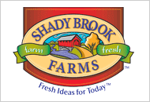
- How are the names of brands and labels placed on meat and dairy products in the supermarket misleading?

- List two ways that chickens are physically different now than in the 1950s, before the green revolution.

- Vince Edwards, the chicken grower working for Tyson, was not given permission to allow the filmmakers inside his chicken coops. Speculate to the reason for this, after watching the segment with Carole Morison, the Purdue grower.

- What are some of the health issues faced by the chickens as a result of their accelerated growth and confined living conditions? What does Carole do to try to mitigate these health problems?

- Explain why farmers are economically bound to the large meat companies.

A CORNucopia of Choices

- About 30% of the United States land mass is used to grow corn. Explain the role that government policy plays in making corn such a dominant crop.

- Why would the large meat suppliers be interested in lobbying the government for subsidies for corn?

- List three products that are partially made of corn.

- What is a CAFO?

- Cattle and other ruminants have evolved to eat grass. What problem has emerged as a result of feeding corn to cattle instead?

Unintended Consequences
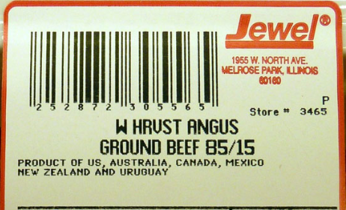
- There has been a noticeable increase in the frequency of food recalls in the last several years. Describe how both the industrialized food system and the government regulatory agencies are behind this problem.

- Kevin Kowalcyk died in 2001 of hemolytic-uremic syndrome caused by eating ground beef contaminated with E. coli O157:H7. What regulatory shortcomings that contributed to his death are his mom working to raise awareness of?

- What change would Kevin’s Law, if passed, make to the meat processing industry?

- What additive is used in some meat fillers to prevent E. coli contamination?

The Dollar Menu

- What kinds of foods are the cheapest? Why?

- Explain how obesity, diabetes, and poverty are linked.

- What is the expected rate of Type II Diabetes in people born after the year 2000? In minorities?

In The Grass

- According to the USDA, Joel Salatin’s farm is “unsanitary.” What was the basis of this opinion? What were the results of the bacterial contamination tests that were performed as comparison?

- How many hogs are slaughtered per year in the Smithfield processing plant in Tar Heel, NC?

- Where do the large meat packing plants get most of their workers?

Hidden Costs

- How is the cheap cost of industrial food “dishonest” or misleading?

- Many of the smaller companies that produced organic and healthier foods have been acquired by larger conglomerate-type companies. Organic food produces are becoming available in places like Wal-Mart. Explain whether this is a good or bad thing.

From Seed to the Supermarket

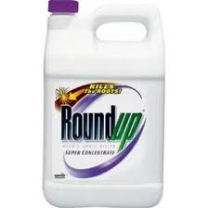
- What is Roundup, and what are Roundup-Ready soybeans?

- Since the Roundup-Ready crop seeds are patented by Monsanto, what happens when a farmer attempts to save his seeds at the end of the season?

- If pollen from a GMO field blows into and pollinates a non-GMO field, does Monsanto have a legal claim?

The Veil

- There has been little debate over the idea of patenting and controlling specific strains of food crops. What does the documentary attribute this to?

- What are “Veggie Libel” laws?

Shocks to the System

- What kind of changes can have huge effects on the food system?

- Explain how consumers can “vote with their wallet” on issues raised in this documentary.

Post-Movie Discussion

During the documentary, the farmer Joel Salatin said,

“If we put glass walls on all the mega-processing facilities, we would have a different food system in this country.”

What does he mean by this? Do you think this is an accurate statement? What specific changes do you think would happen if there was a greater amount of transparency within our food system?

